
RAMAIAH
Institute of Technology
USN | 1 | M | S

(Autonomous Institute, Affiliated to VTU)
(Approved by AICTE, New Delhi & Govt. of Karnataka) Accredited by NBA & NAAC with ‘A’ Grade

SMESTER END EXAMINATIONS – JUNE 2019

Course & Branch | : | B.E. : Computer Science and  Engineering | Semester | : | IV
Subject | : | Design and Analysis of Algorithms | Max. Marks | : | 100
Subject Code | : | CS42/CS1542 | Duration | : | 3 Hrs

Instructions to the Candidates:
- Answer one full question from each unit.

 |  | UNIT – I
1. | a) | - Design an algorithm to merge two sorted lists into one list and compute the time complexity for the same.  - Determine the stable matching set S for the following set of men and women using Gale-Shapley algorithm. | CO1 | (10)
  Men’s preference list | Women’s preference list
    V | A | B | C | D | E
    W | B | C | D | A | E
    X | C | D | A | B | E
    Y | D | A | B | C | E
    Z | A | B | C | D | E
    A | W | X | Y | Z | V
    B | X | Y | Z | V | W
    C | Y | Z | V | W | X
    D | Z | V | W | X | Y
    E | V | W | X | Y | Z
 | b) | - What is the difference between perfect matching and stable matching? Consider an execution of the G-S algorithm that returns a set of pairs S for the given set of men M and women W. Prove that “The set S is a stable matching”.  - Assume you have functions f and g such that f (n) is O(g(n)). For each of the following statements, decide whether you think it is true or false and give a proof or counterexample.  i) log₂ f (n) is O(log₂ g(n))  ii) 2^{f (n)} is O(2^{g(n)})  iii) f (n)² is O(g(n)²). | CO1 | (10)
2 | a) | Consider the following algorithm  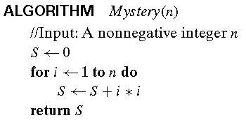  - What does this algorithm compute?  - What is its basic operation?  - How many times is the basic operation executed?  - What is the efficiency class of this algorithm?  - Suggest an improvement, or a better algorithm altogether, and indicate its efficiency class. | CO1 | (06)
 | b) | In the given graph, consider two players P1 and P2 where they select nodes alternately with P1 moving first. Each node has a value bi, represented inside the node. At all times, the set of all selected nodes must form an independent set in G. If the target bound B=20 is to be achieved by P2 is it possible?  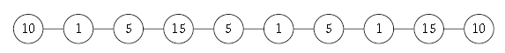 | CO1 | (08)
 | c) | - Construct a proof for “If f(n)= Ω (g) and g(n)= Ω (h) then f(n)= Ω (h)” with an example.  - Construct a proof for “If f is a polynomial of degree d, in which the coefficient ad is positive. Then f = O(n^{d}). | CO1 | (06)
 |  | UNIT – II
3. | a) | - Design a BFS algorithm to determine the traversal in a graph and outline differences between BFS and DFS.  - Identify the number of inversions for the array {1,5,4,8,10,2,6,9,12,11} using divide and conquer method. | CO2 | (10)
 | b) | Compute the DFS and BFS traversal for the following graph with source vertex as 1.  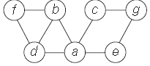 | CO2 | (10)
4. | a) | - Let G be a connected graph, and let L1, L2, . . . be the layers produced by BFS starting at node s. Construct a proof for, “there is an edge of G joining two nodes of the same layer. In this case, G contains an odd-length cycle, and so it cannot be bipartite”.  - Design an algorithm to determine whether a given graph is bipartite or not. Using the same algorithm determine whether the given graph is bipartite or not.  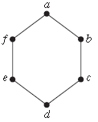 | CO2 | (10)
 | b) | - Sort the following numbers using divide and conquer method.  - Compute the time complexity of merge sort algorithm using unrolling method and deduce the recurrence relation for the same. | CO2 | (10)
  50 | 38 | 40 | 19 | 68 | 70 | 51 | 30 | 12
 |  | UNIT – III
5. | a) | Design an algorithm to find the minimum spanning tree using Kruskal’s algorithm technique and apply the same to the following graph.  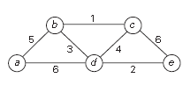 | CO3 | (10)
 | b) | Design an algorithm to construct the optimal prefix code tree for a given set of alphabets and its frequencies. | CO3 | (05)
 | c) | Differentiate between fixed-length encoding, variable length encoding and optimal prefix encoding for a given set of alphabets. Which encoding is more suitable and why? | CO3 | (05)
6. | a) | Compute minimum spanning tree for the following graph using Prim’s algorithm with source node as 1.  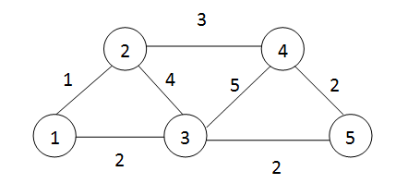 | CO3 | (08)
 | b) | Identify the optimal set of intervals that can be scheduled for the following set on intervals using greedy interval scheduling algorithm.  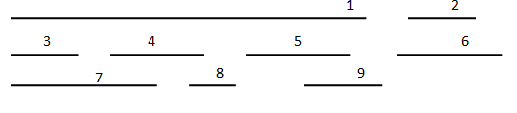 | CO3 | (07)
 | c) | Prove that “Greedy algorithm for interval scheduling returns an optimal set A”. | CO3 | (05)
 |  | UNIT – IV
7. | a) | Calculate the maximum value possible by considering the following instance and knapsack capacity W=10. | CO4 | (07)
  Item | Weight | Value
  1 | 4 | 40
  2 | 7 | 42
  3 | 5 | 20
  4 | 3 | 12
 | b) | Identify the optimal set of intervals with maximum value for the given set of intervals and weights. | CO4 | (08)
  Jobs | Weight | Start time | Finish time
  1 | 2 | 1 | 7
  2 | 3 | 2 | 5
  3 | 7 | 5 | 8
  4 | 8 | 9 | 13
  5 | 3 | 4 | 7
  6 | 2 | 14 | 15
  7 | 3 | 15 | 16
 | c) | Design an iterative procedure to find the optimal weight for a given set of n intervals with their weights ‘w’. | CO4 | (05)
8. | a) | Design a recursive procedure to find the optimal weight of the intervals for a given set of intervals with their weights. What is the disadvantage of this? How can we overcome it using Memoizing method? Explain with suitable algorithm. | CO4 | (05)
 | b) | Apply bellman ford algorithm to find the distance from source vertex ‘a’ to destination vertex ‘t’ in a weighted digraph.  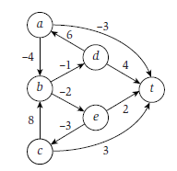 | CO4 | (08)
 | c) | Identify the optimal set of intervals with maximum value for the given set of intervals and weights.  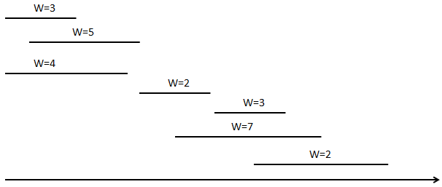 | CO4 | (07)
 |  | UNIT – V
9. | a) | Describe polynomial time reduction? Construct a proof for the following.  - Suppose X is an NP-complete problem. Then X is solvable in polynomial time if and only if P = NP.  - If Y is an NP-complete problem, and X is a problem in NP with the property that Y ≤P X, then X is NP-complete. | CO5 | (10)
 | b) | Discuss Travelling salesman problem and construct a proof for its NP-completeness. | CO5 | (10)
10. | a) | Compute Hamiltonian cycle for the following graph. How can we prove that TSP is complete using Hamiltonian cycle problem?  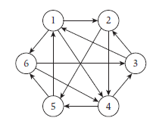 | CO5 | (10)
 | b) | What do you mean by polynomial time reduction? Give a correlation between vertex-cover and independent set problem. | CO5 | (10)

****************

